# SE3061 – User Experience Design

# User Research Plan

NativeCoders



IT21118340 Kumarathunga S. A. D. S.

IT21291364 Rashen W.G.M

IT21267772 Kumanayake I. A.

IT21388934 Siriwardhana S.M.R.R.

# Introduction

TutorME is an innovative mobile application that connects university students with student tutors. It offers a platform for university students to find qualified student tutors efficiently.

This study aims to investigate the what motivates students to seek tutoring services, the challenges they encounter in the process. This will help to understand problems in current process and provide solutions to the challenges faced by students, there by improve user experience.

Additionally, the research also seeks to evaluate their willingness to invest financially in both the tutoring services and study materials. This information will be crucial in persuading potential investors about the business potential of the app.

# Test Objectives

1. Identify factors that motivate students to seek or offer tutoring services
2. Identify challenges faced by students when they want to seek or offer tutoring services
3. Evaluate user's willingness to pay for tutoring services or study materials
4. Identify features or incentives that would enhance user engagement

**Methodology**

Firstly, two structured questionnaires will be distributed among a selected group of thirty university students from different subject areas and academic levels. Afterward, in-depth video interviews will be conducted with four students to gain a better understanding of user behavior and motivation. Google Forms and WhatsApp will be used to conduct the questionnaires, while Zoom will be the platform of choice for the video interviews.

## Questionnaire

Structured questionnaires will be distributed among thirty university students. Students will be selected from the Computing, Humanities, and Engineering faculties. From each faculty, five students will be selected for their tutoring experience, while five students will be selected based on their academic level and seniority.

Two structured questionnaires will be created for tutors and students, using Google Forms, a survey platform developed by Google. Google Forms provides a comprehensive suit

Selected students will be contacted via the WhatsApp messaging platform. After they agree to the interview, the relevant questionnaire will be shared with the participant.

**Questionnaire for Students**

**Section 01**

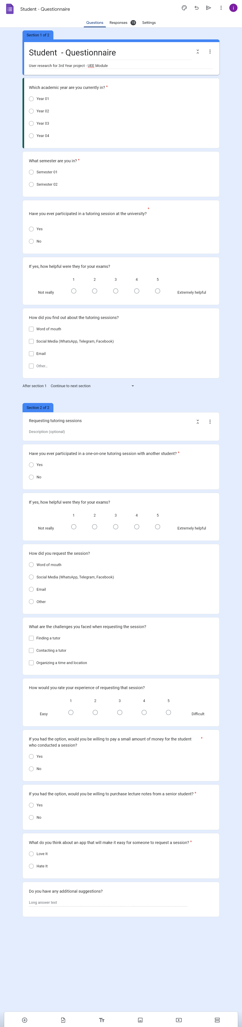

**Section 02**



**Questionnaire for Tutors**

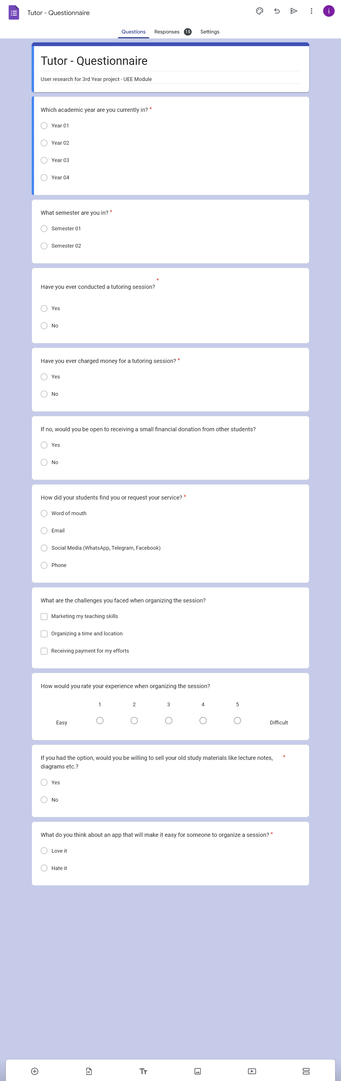

## Video Interviewing

Four students will be selected for a video interview: two to represent the student's perspective and two to represent the tutor's perspective. Students will be selected based on their tutoring experience and academic level.

Selected students will be contacted via the WhatsApp messaging platform. After they agree to the interview, a video interview will be conducted via the Zoom platform.

Interview Questions

**Student:**

* Have ever participated in a one-on-one tutoring session with another student?
* How helpful were they to your exam?
* What motivated you to seek tutoring services?
* How did you request the session?
* Can you describe your experience when requesting the session?
* What are the challenges you faced when requesting the session?
* If you had the option, would you be willing to pay a small amount of money to the student who conducted a session?
* If you had the option, would you be willing to purchase study materials from a senior student?
* What would you think about an app that will make it easy for someone to request a session?
* Do you have additional suggestions for the app?

**Tutor:**

* Have you ever conducted a tutoring session?
* What motivated you to offer tutoring services?
* How did your students find you or request your service?
* How did your students contact you to request your service?
* Have you ever been paid for a tutoring session?
* Can you describe your experience when organizing the session?
* What are the challenges you faced when organizing the session?
* If you had the option, would you be willing to sell your old study materials like lecture notes, diagrams etc.?
* What would you think about an app that will make it easy for someone to organize a session?
* Do you use any separate app to manage your availability and set reminders for yourself when conducting sessions? If so, can you describe it?
* Do you have any additional suggestions?

## Interviewing – All Video Links

**Link:** <https://drive.google.com/drive/folders/1It7_XEsuAzOBSU0OnGVB_mGOKA-zAMH2?usp=drive_link>

Interview 01

**Participant**: Sathsarani Wijeratne

**Description**: 3rd year Information Technology student

**Role**: Tutor

**Date**: *2023-09-03*

**Link:** <https://drive.google.com/file/d/1ReHpQ4KsjQ8TbbwVjMKX2fWNRXD8oDFO/view?usp=drive_link>

**Script:**

Manuka: Hey Sathsarani, I'm Manuka, and these are my teammates Dilru, Rumesh, and Isuru. We're developing an app that will help university students connect with tutors. So, we're really excited to talk with you today to get your thoughts as a tutor. We think your insights will be really helpful for us in making our app even more user-friendly. First can you introduce you yourself?

Sathsarani: Hi everyone, My name is Sathsarani, and I'm currently in my third year of studying Information Technology.

Manuka: Have you ever conducted a tutoring session?

Sathsarani: Yes, I've done quite a few tutoring sessions, mostly covering programming-related topics.

Isuru: What motivated you to offer tutoring services?

Sathsarani: I just really wanted to help my friends do well in their studies. Back in my university days, I saw some of my friends really struggling with tough subjects. That's when I got the idea to set up my very first tutoring session. It felt amazing to see my friends make real progress in their studies.

Isuru: How did your students find you or request your service?

Sathsarani: Usually, my students discovered me through a mix of recommendations and online presence. It was often friends who had experienced my tutoring would suggest me to others. On top of that, I used to upload my tutoring sessions on YouTube, and, some people came across them and reached out to me.

Rumesh: How did your students contact you to request your service?

Sathsarani: They usually reached out to me through email or text messages.

Rumesh: Have you ever been paid for a tutoring session?

Sathsarani: Yes, back in my university days, I noticed that some of my fellow students were really grateful for my tutoring help and even wanted to pay me for it. It was a pleasant surprise and a big help financially. It not only eased my money worries but also made me realize how much they valued what I was doing.

Manuka: Can you describe your experience when organizing the session?

Sathsarani: Setting up a tutoring session takes some thoughtful steps. First, I chat with the student to figure out when and where works best for them. If it's an online session, we decide on the video call platform. Next, I change the session material to match what the student's studying, so it's relevant. When we're in the session, I keep things organized by following a plan. We go through what they need to learn, and I'm always open to questions and discussions to make sure they really get it.

Isuru: What are the challenges you faced when organizing the session?

Sathsarani: When it comes to setting up tutoring sessions, I've faced a few problems. Scheduling can be a real puzzle, especially when exams are near. Finding a peaceful spot for face-to-face sessions without interruptions is not easy either. Plus, working with students who have different learning preferences means I've got to be flexible and really good at talking things through.

Dilru: If you had the option, would you be willing to sell your old study materials like lecture notes, diagrams, etc.?

Sathsarani: Yes! I'm believe in sharing knowledge and resources. I thought about selling my old study materials like lecture notes and diagrams to help fellow students, but I don't want to burden them with high costs. I'm leaning towards giving them away for free. It's a way for me to showcase my teaching skills and assist others at the same time.

Rumesh: Akke, What would you think about an app that will make it easy for someone to organize a session?

Sathsarani: I think that is really great idea. Being a tutor myself, I know firsthand how tricky it can be to juggle schedules, handle payments, and keep in touch with students. Having an app tailor-made for managing tutoring sessions could really make things smoother, making life easier for both tutors and students.

Manuka: Do you use any separate app to manage your availability and set reminders for yourself when conducting sessions? Can you describe it?

Sathsarani: Right now, I rely on a calendar app to keep track of my schedule and remind me of important events. I put in all my tutoring appointments, study sessions, and other personal commitments into the calendar. It's good for preventing conflicts in my schedule, but it's missing specific features that would make tutoring even easier. Like, it doesn't have any way for me to handle payments or communicate directly with my students. So, I'm pretty excited to check out a tutoring app that's designed just for those needs.

Isuru: Do you have any additional suggestions?

Sathsarani: Yes. What do you think about adding a feature where tutors can assess students' understanding of the topics they want to concentrate on.

Manuka: Yes. We will definitely consider about it. Thank you so much for taking the time to do this interview. We genuinely appreciate it!

Sathsarani: Thank you guys for having me. I wish you all the very best.

Interview 02

**Participant**: Dananjaya Siriwardhana

**Description**: 3rd year Data Science student

**Role**: Tutor

**Date**: *2023-09-15*

**Link*:***[*https://drive.google.com/file/d/1yQ80PozVElbcb1F1Fsc71fo_3I-IHYjM/view?usp=drive_link*](https://drive.google.com/file/d/1yQ80PozVElbcb1F1Fsc71fo_3I-IHYjM/view?usp=drive_link)

**Script:**

Dilru: Hey Dananjaya, I'm Dilru, and these are my teammates Manuka, Rumesh, and Isuru. We're developing an app that will help university students connect with tutors. In this interview, we'd like to ask you a few questions and gather your thoughts as a tutor. We think your insights will be really helpful for us in making our app even more user-friendly. First can you introduce your yourself?

Dananjaya: Hi everyone, My name is Dananjaya! and I'm currently in my third year of studying Data Science.

Dilru: Have you ever conducted a tutoring session?

Dananjaya: Yes, I've conducted several tutoring sessions, primarily focusing on topics related to engineering and mathematics.

Manuka: What motivated you to offer tutoring services?

Dananjaya: In previous years, I noticed some of my classmates having a hard time with certain subjects. That's when I thought of starting some tutoring session, to help them.

Isuru: How did your students find you or request your service?

Dananjaya: Most of my students find me through word of mouth or online. It's usually friends who've had tutoring sessions with me and then recommend me to others. And I used to maintain a blog about engineering related topics, so some people stumbled upon them and got in touch.

Rumesh: How did your students contact you to request your service?

Dananjaya: They usually reached out to me through email or WhatsApp. It is not easy for them to find me as there is no specific platform for this.

Rumesh: Have you ever been paid for a tutoring session?

Dananjaya: Yes, I did some research and found out that there are so many students out there who could really use some extra academic help. So, I started offering tutoring services to students who needed it. It actually helped improve my finances without putting too much pressure on my parents.

Manuka: Can you describe your experience when organizing the session?

Dananjaya: When I'm setting up a tutoring session, I like to keep things organized. First, I chat with the student to find out a time and location, it's most convenient for them. If it's going to be online, we choose a video call platform that works for both of us. Then, I create some the study materials to help them understand the session further. During the session, We discuss what they need to learn, and I give them a small quiz to make sure they really understand everything.

Isuru: What are the challenges you faced when organizing the session?

Dananjaya: When arranging tutoring sessions, scheduling and payment are the most tricky parts, especially trying to find that perfect time when both of us are available, and making sure everything gets settled smoothly.

Dilru: If you had the option, would you be willing to sell your old study materials like lecture notes, diagrams, etc.?

Dananjaya: Yes, but you know, I've been thinking that sharing them for free might actually be a better idea. I mean, you can easily get old lecture notes from another senior without paying anything, right? So, instead of charging for them, I give them away for free. This way, I can not only showcase my teaching skills but also lend a hand to others. It's a win-win situation.

Rumesh: What would you think about an app that will make it easy for someone to organize a session?

Dananjaya: I think that is really great idea. Being a tutor myself, I know firsthand how difficult it can be to juggle schedules, handle payments, and keep in touch with students. Having an app specifically made for managing tutoring sessions could really make things easier for both tutors and students.

Manuka: Do you use any separate app to manage your availability and set reminders for yourself when conducting sessions? Can you describe it?

Dananjaya: Currently, I'm using Google services to manage my schedule and set reminders for important stuff. I put all my tutoring sessions, study meet-ups, and personal plans into my Google Calendar. It's great for avoiding schedule clashes, but it lacks some features that could make tutoring smoother. For instance, there's no built-in payment system or direct communication with my students. That's why I'm really looking forward to trying out this new tutoring app, specially designed to cater to those needs.

Isuru: Do you have any additional suggestions?

Dananjaya: Yes. What do you think about adding a feature where tutors can send a quiz to students, so they can know what topics to focus on.

Dilru: Yes. We will definitely consider about it. Thank you so much for taking the time to do this interview. We genuinely appreciate it!

Dananjaya: Thank you guys for having me. I wish you all the best.

Interview 03

**Participant**: Rosara Dayaratne

**Description**: 3rd year Software Engineering student

**Role**: Tutor

**Date**: *2023-09-16*

**Link:** <https://drive.google.com/file/d/1bHxC8pnL_uWpyrf3bxMRPMUhrk96pG0N/view?usp=drive_link>

**Script:**

Dilru: Hello Rosara, I'm Dilru, and these are my teammates Manuka, Rumesh, and Isuru. We're developing a mobile application that will help university students connect with tutors. In this interview, we'd like to ask you a few questions and gather your thoughts as a tutor. We think your insights will be really helpful for us in making our app even more user-friendly. First can u introduce ur urself?

Interviewee: Hi everyone, My name is Rosara! and I'm currently in my third year of studying Software Engineering.

Dilru: Have you ever conducted a tutoring session?

Interviewee: Yes, I've conducted several tutoring sessions, primarily focusing on topics related to java and mobile app development.

Manuka: What motivated you to offer tutoring services?

Interviewee: Some of my classmates told me they are having a hard time with programming subjects. That's when I thought of starting some tutoring session, to help them.

Isuru: How did your students find you or request your service?

Interviewee: Most of my students find me through word of mouth or online. And I maintain a youtube channel about mobile app development, so some people watched them and got in touch.

Rumesh: How did your students contact you to request your service?

Interviewee: They usually reached out to me through email or WhatsApp.

Rumesh: Have you ever been paid for a tutoring session?

Interviewee: Yes, I did some research and found out that there are so many students out there who could really use some extra academic help. So, I started offering tutoring services to students who needed it. It actually helped improve my finances without putting too much pressure on my parents.

Manuka: Can you describe your experience when organizing the session?

Interviewee: I only conducts online sessions. First, I chat with the student to find out a time and video call platform that works for both of us. Then, I create some the study materials to help them understand the session further. During the session, We discuss what they need to learn. After the session, I give them a some coding problems to make sure they really understood everything.

Isuru: What are the challenges you faced when organizing the session?

Interviewee: Trying to find a time perfect for both of us can be challenging. Next pain point is payment process. Since there isn't a dedicated platform for this kind of thing, I had little idea about how much to charge and how to do the payment process.

Dilru: If you had the option, would you be willing to sell your old study materials like lecture notes, diagrams, etc.?

Interviewee: Yes, If there are students willing to buy them for a fair price.

Rumesh: What would you think about an app that will make it easy for someone to organize a session?

Interviewee: I think that is really great idea. Being a tutor myself, I know firsthand how difficult it can be to handle scheduling and payments. Having an app specifically made for managing tutoring sessions could really make things easier for both tutors and students.

Manuka: Do you use any separate app to manage your availability and set reminders for yourself when conducting sessions? Can you describe it?

Interviewee: Yes, I put all my tutoring sessions, study meet-ups, and personal plans into the Calendar app. It's good for avoiding schedule clashes. I use whatsapp to communicate with my students. But If there was single tutoring app with all thses features, It would be super convenient.

Isuru: Do you have any additional suggestions?

Interviewee: No, Seems like this app covers every important feature.

Dilru: Thank you so much for taking the time to do this interview, Sashin. We really appreciate it!

Interviewee: Thank you guys for having me. I wish you all the best.

Interview 04

**Participant**: Sasini Nimesha

**Description**: 1rd year Computer Science student

**Role**: Student

**Date**: *2023-09-14*

**Link:** <https://drive.google.com/file/d/1CA31GiZzQK0_b0Z6jL-0dueaFLQSiS1W/view?usp=drive_link>

**Script:**

Dilru: Hey Sasi, I'm Dilru, and these are my teammates Manuka, Isuru, and Rumesh. We're developing an mobile application that will help university students connect with tutors. So, we're really excited to talk with you today to get your thoughts as a student. We think your insights will be really helpful for us in making our app even more user-friendly. First can u introduce your yourself?

Sasini: Hi everyone, My name is Sasini, and I'm currently in my first year of studying Computer Science.

Dilru: Have you ever participated in group tutoring sessions?

Sasini: Yes. I have participated in several group tutoring sessions.

Dilru: Have you ever participated in a one-on-one tutoring session, with another student?

Sasini: Yes. I have also participated in one-on-one tutoring session with another student.

Dilru: What was your experience with them? How helpful were they to your exam?

Sasini: They were really helpful. In my experience one-on-one tutoring session are much better than group tutoring sessions. It is easier to communicate with the tutor,

Manuka: What motivated you to seek tutoring services?

Sasini: I was struggling with several subjects. So I felt it would be better to ask help from someone.

Isuru: How did you request the session?

Sasini: I communicated with them the via WhatsApp.

Isuru: Can you describe your experience when requesting the session?

Sasini: It wasn't easy. There is no specific platform to find this type of service. Therefore I had to lot of searching and asking around to find a tutor.

Rumesh: What are the challenges you faced when requesting a session?

Sasini: Finding a tutor was the main challenge. As I mentioned earlier, there isn't a dedicated platform for this kind of thing. And even when I did manage to find a tutor, it was still tricky to figure out if they were the right fit for me or not.

Manuka: If you had the option, would you be willing to pay small amount of money for the student who conducted the session?

Sasini: Absolutely, especially if they made a difference in my studies.

Dilru: If you had the option, would you be willing to purchase study materials from a senior student?

Sasini: Yes. But I will need to get a preview of the materials before purchasing, just to make sure it's worth the price.

Rumesh: What would you think about a app that will make it easy for someone to request a session?

Sasini: I think that is really great idea. It would save me lot of time, if an app like that exist.

Dilru: Do you have any additional suggestions?

Sasini: Yes. What do you think about adding a feature, which allows students to send a list of topics to our tutor. That way we can communicate what specific areas we'd like to concentrate on

Dilru: Yes. We will consider about it. Thank you so much for taking the time to do this interview. We genuinely appreciate it!

Sasini: Thank you guys for having me. I wish you all the best.

# Participant Profiles

The table below provides a breakdown of the participants selected for video interview:

|  |  |  |
| --- | --- | --- |
| **Name** | **Demography** | **Date & Time** |
| *Sathsarani Wijeratne* | *3rd year Information Technology student at SLIIT.* | *2023-08-25 18.30* |
| *Dananjaya Siriwardhana* | *3nd year Data Science student at SLIIT.* | *2023-09-18 18.30* |
| *Rosara Dayaratne* | *3rd year Software Engineering student at SLIIT.* | *2023-09-22 18.30* |
| *Sasini Nimesha* | *1st year Computer Science student at KDU.* | *2023-09-20 18.30* |

**Tasks and Scenarios**

|  |  |  |
| --- | --- | --- |
| **Task** | **Target** | **Probe** |
| Tutor - Login & Register | User registers as a tutor by providing details and then login to land in the tutor home page. |  |
| Publish class | Tutor publishes a class by adding class details and the session times. |  |
| Upload study materials | Tutor uploads a study material to be downloaded by a student. |  |
| Make a withdrawal | Tutor withdraws money from the wallet after conducting a session. |  |
| Student - Login & Register | User registers as a student by providing details and then login to land in the student home page. |  |
| Make session request | Student searches a class by the category and then requests a session with the tutor by providing details. |  |
| Download study materials | Student downloads a study material to be uploaded by a tutor.. |  |

# Plan for Data analysis

|  |
| --- |
| Interview transcripts were prepared to better understand the user responses. User responses were analyzed both qualitatively and quantitatively. Quantitative data were entered into an excel sheet to visualize using bar charts and pie charts. Qualitative data was thoroughly reviewed and categorized to identify recurring themes and patterns in the feedback. We conducted in-depth interviews with a diverse group of university students who have experience as tutors and those who seek tutoring services. These interviews delved into various aspects, including user preferences, pain points, and expectations within the context of a student tutor app.  For the quantitative analysis, responses were organized into structured categories and entered into an Excel spreadsheet. This allowed for the creation of informative visualizations such as bar charts and pie charts. These graphical representations aided in presenting statistical insights into user preferences and usage patterns, providing valuable quantitative data for decision-making.  On the other hand, the qualitative data analysis involved a thorough examination of the interview transcripts. We identified recurring themes, feelings, and insightful suggestions shared by participants. This qualitative analysis helped us better grasp the finer details and hidden reasons behind user responses, allowing us to discover what users really need, what worries them, and where we could make the app better.  By combining both quantitative and qualitative analysis methods, we aimed to gain a comprehensive understanding of user needs, enabling us to make informed decisions during the app development process and ensure that the final product aligns closely with the expectations and preferences of both student tutors and those seeking tutoring services within the university community. |
| Two separate questionnaires were designed and conducted using Google Forms, one for students comprising 15 questions and another for tutors with 10 questions. These questionnaires were distributed to gather valuable user feedback for our student tutor app.  The collected data was then analyzed through Google Forms analysis tools. For the student questionnaire, we sought insights on various aspects, including user preferences, experiences, and expectations from the app. On the other hand, the tutor questionnaire focused on understanding tutor perspectives and requirements within the app.  Google Forms' analysis features allowed us to efficiently process and visualize the gathered data. We used the platform's built-in tools to generate summary statistics, charts, and graphs, providing a clear and organized overview of the responses. This analysis enabled us to identify patterns and areas for improvement based on user feedback from both students and tutors. |

**Questionnaire Results**

Student

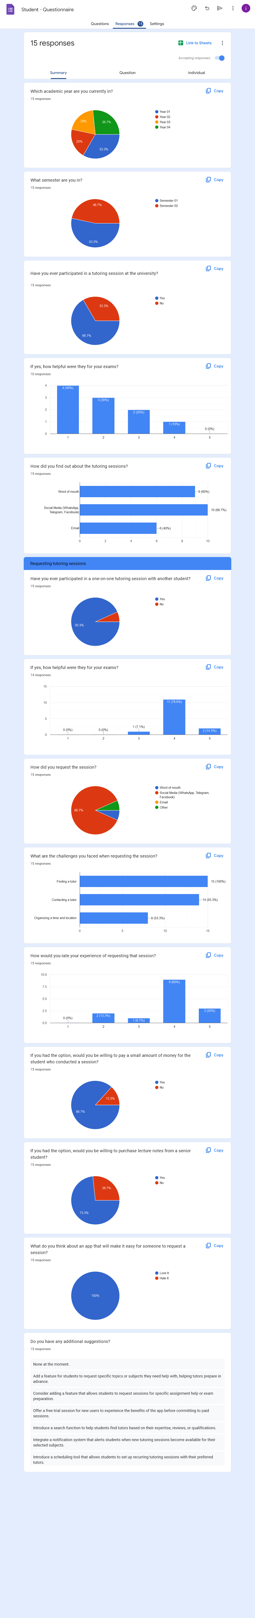

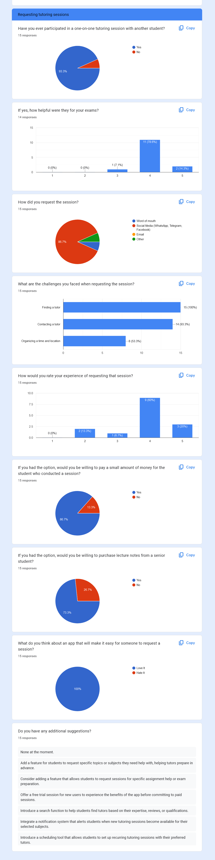

Tutor

